Game Design Document Outline for:

Disengaged

The Basics

Game:
Players take on the role of USAF Major Tom Bowman who wakes up alone on a spaceship orbiting Europa with rapidly failing systems. Bowman must work to restore the ship to working order whilst trying to discover what happened to the crew.

Genre:
This is primarily a story-heavy puzzle game. It’s inspired by games like SOMA, To The Moon and Alien: Isolation. It’s also inspired by the films The Martian, Event Horizon and 2001: A Space Odyssey.

Audience:
The game is intended for players interested in space, puzzles and a focus on narrative.

Unique Selling Point(s):
Disengaged features an isolated, unreliable narrator: USAF Major Tom Bowman. The outcome of the story is influenced by player choice, primarily the way they go about fixing the ship. The different endings add some replayability to the game. Disengaged also uses gravity as a puzzle mechanic, allowing players to reach areas or move objects that would be difficult to do otherwise.
Story

Plot:
USAF Major Tom Bowman awakens on the Janus I, a spaceship currently orbiting Europa, one of Saturn’s moons. With the ship’s alarms blaring, Bowman makes his way from his small bedroom to the bridge. He reviews the ship’s logs at the Bridge Computer and learns that, while he slept, the Janus flew through a meteor shower, possibly a result of their crossing the asteroid belt, which damaged several systems onboard the ship. Currently most important is the lack of power - Bowman can’t learn what other systems need repair until he realigns and reconnects the solar panels, which will require a spacewalk. As he heads to the primary airlock, Bowman thinks he sees someone disappear into a room, but, upon investigation, finds nothing.
Bowman can repair the Comms, Engine, and Life Support in any order, and even while working on the other systems, but he is working under time pressure to fix the Engine and Life Support before the Janus’s orbit decays too much or the air runs out. While completing these tasks, Bowman is plagued by hallucinations and flashbacks reminding him of the guilt he feels for the accidental deaths of his friends during his time in the Air Force.
To fix the engines:
- Bowman receives the quest from the ship’s computer, which informs him that the engines have stopped working.
- Bowman reasons* to himself that he’d better see if the ship’s engineer had any notes or manuals that would help him figure out exactly what’s wrong.
- In the Engineering Lab, Bowman finds Sage’s Notes, Sage’s Manual and Sage’s Password, which allows the player to access her personal computer and learn more about Sage. Her password is “fibbonacci”.
- Bowman uses the manual to deduce what’s wrong with the engines at the ship’s main computer. Sage’s notes and the manual explain what parts he will need to build a replacement part.
- Bowman collects the parts from the Cargo Hold.
- In the Engineering Lab, Bowman uses the notes and manual to construct the part.
- A ghost appears over his shoulder and Bowman begins to doubt himself as he works.
- Bowman goes on a Spacewalk to the Engines to replace the part from outside.
- On his way back inside, Bowman sees his dead squad standing on the ship’s hull.
*Players will initially be set loose to proceed as they see fit. If no progress has been made after a certain amount of time, Bowman might mutter to himself something about where to go or what to do.

To fix the Comms:
- Bowman receives the quest from the Bridge Computer.
  - There’s a sticky note with Joss’s password, “youshallnotpassword”.
- Bowman journeys to the Cargo Hold to find a replacement antenna.
- He sees shadows hiding in the Cargo Hold, but finds nothing upon investigation.
- After finding a replacement, Bowman goes out for a spacewalk.
- He reaches and replaces the antenna with little difficulty.
- On his way back, Bowman loses his grip and flies out to the end of his tether.
  - He has a flashback to a time when his jet was shot down.
- As the tether snaps him back, Bowman comes back to his senses.
- Bowman makes his way back inside and to the Bridge Computer.
- Using Joss’ notes, Bowman realigns the Communications array.
  - This is a puzzle involving math and angles and stuff.
  - Joss’s notes are a mix of goofy sketches and bad jokes, with the actual math stuck somewhere in between.
- Tom receives some messages from the crew, plainly revealing they are on the surface of Europa.
- Bowman also has a brief flashback of him trying to contact his squad just after they died.

To fix the Life Support:
- Bowman receives the quest from the ship’s computer, which informs him that the Life Support has stopped working.
- Bowman heads to the Life Support Hub in the Medbay to find out exactly what’s wrong.
- Bowman learns that the Water Tank Coolant Line is cracked and the Oxygen Scrubber’s settings have gone wonky.
- The cracked Coolant Line has caused the Medbay to become freezing cold and make the Life Support Hub difficult to access.
- Using Duct Tape found in the Cargo Hold, which he may have found when doing a different quest or may have to retrieve for this, Bowman easily repairs the Water Tank.
- With the Water Tank fixed, Bowman can properly access the Oxygen Scrubber’s controls.
- He finds the password for Mac’s computer, “getdunkedon.”
- Bowman learns that the Oxygen Scrubber’s settings for cleaning the oxygen have gone out of whack due to condensation from the broken Coolant Line. He must reenter the chemical balance of breathable oxygen.
- Bowman heads to the Science Lab in hopes of finding something that will help.
- He finds some scribbled notes from Will Beake that are difficult to read but might be the right thing, along with Beake’s password, “alexanna”.
- Back at the Life Support Hub, Bowman is doubtful of the notes. He has nothing to fact check them again, as this was not a foreseen occurrence.
- Bowman has a brief flashback to a situation in his Air Force days of a similar situation.
- He was unsure of the information he had been supplied with, but had acted on it anyway. His squad was slaughtered due to the faulty information.
- Bowman correctly inputs the chemical formula. The lights dim as the system recalibrates.
- Bowman is briefly surrounded by the forms of his fallen squad, but they disappear when the lights return to full power.
These bullet points highlight the primary events and puzzles of each quest. Smaller puzzles, such as the best placement of a limited amount of duct tape on the water supply tank or figuring out the sorting system for parts in the Cargo Hold, things of this nature, can also be included.

After Tom has fixed everything, he has a hard flashback that quickly reveals what happened in his past that haunts him. It is revealed that he, as a Combat Control specialist, decided to use what he knew to be possibly faulty information, due to his own negligence, in a combat situation. The decision caused his squad to be caught in an enemy killing field and Tom had to listen as they were gunned down. Though hesitation or waiting for more accurate information may have led to the same result, Tom holds himself responsible.
Tom comes back to his senses with alarms blaring once again. His crewmates’ Europa lander has already launched and the Janus is not yet in position. Tom can use either the computer in the Bridge or the Cargo Hold to move the ship into position. He then heads to the Vehicular Airlock to guide the crew threw the remnants of the meteor shower and get them safely onboard. As they come inside, they express joy and relief at being safely back on board the Janus and concern for Tom, who appears a bit shaken, though overall more relaxed and content than he had been on the way to Europa. Personally, Tom feels he has somewhat redeemed himself. He briefly sees the squad leader standing behind the crew, though he doesn’t appear angry.
Later, the crew is seen celebrating the successful mission onboard the Janus. Mac has had a bit too much to drink and jokingly kisses Joss. Everyone goes quiet and Mac begins to realize what she’s done. Sage gets up, as if to remove herself from the situation but bumps Joss into Mac, which happens to be just what the two needed. More cheering. The ship is seen floating towards a small blue dot near a big yellow one.

Tom finds the crew’s computer passwords as he explores, allowing him to delve deeper into their personal lives and learn more about them. Reading through each crewmember’s personal files results in a brief cutscene focusing on that character. Tom can also explore some files on the Bridge Computer to learn more about the Janus mission and read dossiers on his crewmates.
Failing to repair the engines or life support in time will result in the entire crew being killed. Tom will sit in silence on the bridge as Europa pans into view and the hull starts to glow from entering the atmosphere.
Failing to repair everything before the Europa lander launches leaves Tom as the only surviving crewmember. He is seen sitting in silence in the mess hall, surrounded now by the dead squad and dead crew. This is the end of the Janus missions.

Story Vehicles:
Bowman talking to himself and explaining what he has to do would be a bit strange. Instead, the story and instructions will be given through interaction with objects, the ship’s log and the crew’s personal logs.

CHARACTERS
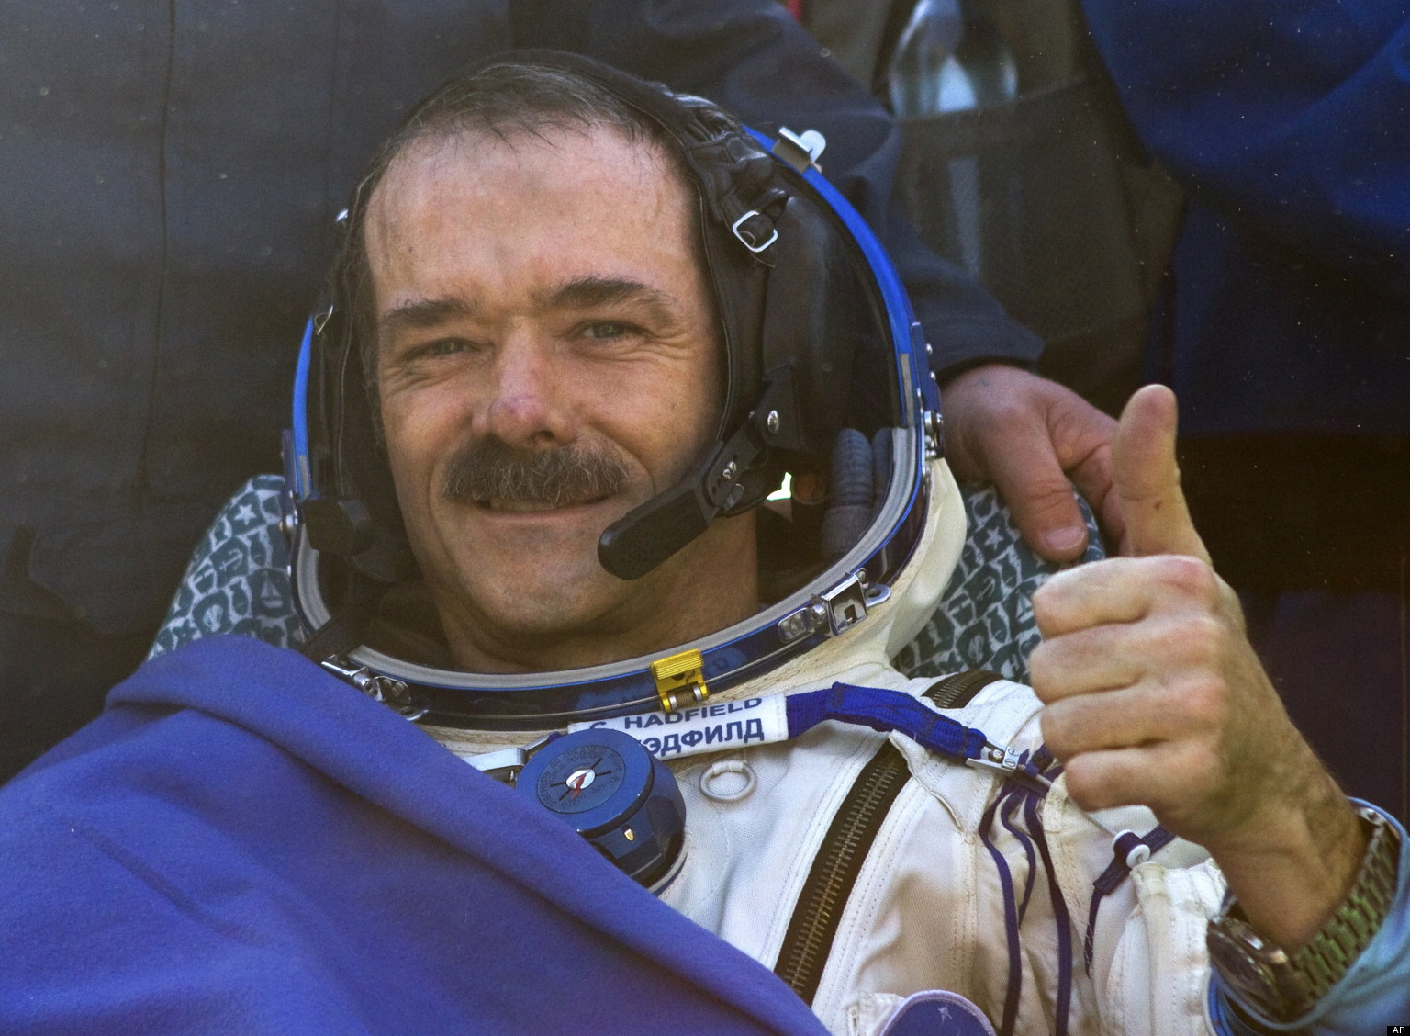
The Player Character:
Tom Bowman - Protagonist - Pilot of the Janus I mission - Bowman is an extrovert and good-natured but is also a bit of a neat freak and can be very private. He prefers to be around people so he doesn’t have to be by himself, prefers to keep his head down and work hard. He doesn’t like down time. Bowman, to some extent, feels like helping the Janus mission be safe and successful will be his best contribution to mankind. He feels some guilt over his service and feels like he needs to make it up to himself and to the people around him. As he explores and fixes the Janus, Bowman talks to himself quite a bit, almost like a running commentary, and experiences hallucinations and flashbacks to his time in the Air Force, as well as his home life and training at NASA with his crewmates.
In the Air Force, Bowman had two primary incidents that he feels had a big impact on his life. First, there was the time he was shot down over enemy lines. He had initially lost consciousness when he was falling and thought he was dead when he woke. He barely managed to open his parachute in time. He met little resistance navigating back to friendly territory. The other incident was when he was positioned as a 2nd Lieutenant Combat Control specialist, essentially a mobile one-man air traffic controller. During an operation, Bowman received what he knew was possibly faulty intel and decided to act on it rather than wait for verification, feeling that the lives of fellow soldiers might be forfeit if they had to wait any longer. Unfortunately, Bowman’s squad was led directly into an enemy killing field. He had to listen as they were shot down. He still feels directly responsible for their deaths and hopes to find a way to make up for it.

OTHER CHARACTERS:

Ground Control/NASA - Their goal is to see the success of the Janus mission or to have the astronauts return to Earth alive. They serve exclusively as a hint system for the player.

Joss McRae - Commander of the Janus Mission - While he knows when to be serious, Joss likes to joke around a lot, even going so far as to play practical jokes on his crew that they don’t always find funny. Joss thinks he’s generally beloved but there are one or two people who are a bit sick of his shenanigans. Despite his outgoing and jovial personality, Joss knows when to buckle down and be serious. That switch in his personality from jokester to commander can throw people off a bit. Joss is ultimately more concerned for the well-being of his crew more than the actual purpose of the Janus mission and feels that one of the best ways to look out for them is to keep their spirits high with an endless barrage of jokes, puns, and pranks. Joss has a semi-serious girlfriend back on Earth but he’s not entirely sure if she’ll wait for him to return from the seven-year mission. If she doesn’t, he thinks he won’t be too upset. After all, he’s pretty charming - he’ll find someone new soon enough. Overall, Joss serves as comic relief.

Sage Crusan - Mechanical Engineer and Chemist - Sage is fairly quiet, though she likes to be around people. She fought with Ground Control to bring a few extra books with her on the mission. Sage is fairly kind and acquiescent, though she knows when to say no to people. She prefers the feel of a real book to that of a Kindle or some other kind of e-reader and was actually a bit offended when Ground Control offered to give her a gift card to get her books on an e-reader rather than bring the physical copies. Sage particularly likes horror and crime books, as they have formulas the same way engineering and chemistry do. She likes to see if she can find the formula and solve the problem long before the book ends. Sage has a very mathematical, logical mind, though she fears being judged by her other crewmates for being too nerdy. She’d like to branch out a bit and make friends and she sees the Janus mission as a “prime opportunity.” Mac is secretly working with Sage about Mac’s crush on Joss and how to bring that dream into reality. Sage enjoys the attention and the opportunity to try out some romantic “formulas.” Joss does not pull pranks on Sage, as he doesn’t know if she could handle it. Also, he’s afraid she’s got some serious pent-up nerd rage. Sage is fairly close with her brother, but not her parents. She’ll probably stay on as a mechanical engineer at NASA when she gets back.

Will Beake - Botanist and Biologist - Will is a large, intimidating and serious man, though he’s quite the gentle giant once you get to know him. As a father of two, it was hard for him to sign on for such a long mission, but his kids thought it would be “totally awesome.” His wife was a bit upset, but she supports him. He’s worried his kids won’t think their dad being gone for seven years is “totally awesome” when he gets back and he checks his email every day for new messages from his family. He hopes to be as present in their lives as possible from the other side of the asteroid belt. Will is particularly excited about the possibility of being the man to find life on Europa. Will gets on quite well with Bowman and the two plan to remain close friends. While Will appreciates Joss’s sense of humor, and occasionally writes down a joke to tell his kids, he’s finding that the longer the mission goes on, the more his patience wears thin for Joss’s pranks. He doesn’t know if he’ll say anything or just tough it out. Either way, this is his last mission for NASA. He plans on opening a flower shop and breeding new kinds of flowers when he gets back.

Mackenzie “Mac” Cavanaugh - Copilot and Medic - Mac is loud, proud, and likes to tackle problems head on. Her biggest concern with the length of the mission would be the enormous amount of time spent just getting to and from Europa. She hates downtime and is always on the move. She really hopes she’ll get the chance to see the Red Eye of Saturn in person. Mac is a hardcore gamer and trashtalker. While Mac prefers FPSs to MOBAs, her absolute favorite game is Rocket League. She’s got a bit of a crush on Joss and tries to prank him back, but is never quite as successful as he is. She secretly goes to Sage for her thoughts and advice on the situation. As far as being the ship’s doctor goes, she warned the rest of the crew before they left that she doesn’t get the concept of “bedside manner,” so they should get hurt at their own risk. While she’s certainly capable, Mac views her Medic position as annoying. She wants to learn as much as she can from Bowman so she could possibly move up to primary pilot on a future mission.

Captain Rick Piper - Captain Piper was on the ground and in charge of the squad that was slaughtered during a special operation. He’s a rough customer in the military who’s seen more than his fair share of firefights. He lives for excitement and his little tolerance for bureacracy, indecision or inexperience. He gets on fairly well with Bowman, but sees him as someone who still needs some training and needs to learn how to make the tough decisions, maybe almost as a younger brother but with a military spin. The two are friends, but there’s a certain tension to their relationship, possibly due to the nature of their ranks in the military.

Gameplay

Player Experience:
The game looks to inspire some fear and hesitation at points, but mostly curiosity. Each of the endings should have a bittersweet feel.

Player Character Actions:
The player will search for and move objects in order to solve puzzles. When facing Bowman’s hallucinations, they’ll need to simply talk their way through the problem. They’ll also read ship’s logs and the crew’s personal logs to learn more about current events.

Player Character End Goal:
The player should aim to completely repair the ship, learn the entire backstory by reading everything and save the crew. Saving the crew provides some closure and validation for Bowman, and hopefully the player.

Enemies:
There are not any traditional enemies. Instead, Bowman struggles against people from his past through hallucinations.

Combat:
Because there are no traditional enemies, there is not traditional combat. Rather, Bowman talks and interacts with his hallucinations in order to calm down and allow the player to learn more about him.

Obstacles:
Bowman has to repair the power generator, engines, the communications system and the life support on the ship. Each primary system will have two or three subsystems that must be restarted, fixed or recalibrated, some of which may require a spacewalk. Bowman only has a limited amount of time to fix the ship, as the air is running out and the ship itself is slowly falling out of Europa’s orbit. There will be various puzzles involving the ship’s systems and how to repair them or find the parts needed the player must solve.

Replayability:
Players may wish to experience all three possible endings, especially if they don’t get the “best” ending on the first try.

The Game World

Environments:
The game take place primarily inside the Janus ship, though there will be a few short spacewalks that take the player to the outside of the ship. There may also be brief cutscenes on Earth or the spaceship on the way to Europa that fill in the backstory and flesh out the characters more. Locations inside the Janus would be places like the medbay, the bridge, the cargo hold, a science lab, engineering lab, etc. Locations the player might visit on the outside of the ship would be the engines and the communications array.

Key Locations:
The bridge would probably be the most important location in the game. This is where the player will learn what needs to be repaired and also receive hints about how to achieve their goal. The computer in the bridge could also collect the logs the player finds as they explore, so they can review them at any time.
Main Shaft:
Bridge
Crew’s Rooms
Small Storage Space
Medbay
Airlock
Right Shaft:
Vehicular Airlock
Cargo Hold
Engineering Lab
Left Shaft:
Mess Hall/Meeting Room
Recreation Area
Science Lab
Outside the Ship:
Engines
Solar Panels
Comms Array

Game Flow:
Bowman’s Room > Bridge > Engineering, Cargo Hold & Space Walk(Fix Engines)/ Medbay & Science Lab(Fix Life Support)/ Cargo Hold & Space Walk (Fix Comms) > Vehicular Airlock > End

The other crewmates’ rooms are completely open for Bowman to explore. However, their computers’ all have passwords. Bowman will find these passwords in various places as he goes about fixing the ship, mixed in with notes, or marked in a book or simply on a sticky-note on the Bridge. The player is free to explore the ship, otherwise.

Interactivity:
The player will be able to interact with many of the items found on the ship to either try and find the solution to a puzzle or learn more about the ship, the crew or the mission. Interaction with items on the ship ranges from picking them up, to hearing Bowman’s thoughts about the object to initiating a puzzle sequence or cutscene. They will also be able to access the computers on the ship, located in the bridge, medbay, engineering and science labs and the crew’s personal rooms.

Training:
The computer on the bridge will give basic instructions to the player on how to restore the ship’s systems and will walk the player through restoring the ship’s power, which will require a spacewalk. The player is then given free reign. Repairing and recalibrating the comms array will be the easiest, so the player can contact Ground Control for more in-depth hints, though this may affect the ending, as comms is, possibly, the least critical system. The player will be warned of this.

Map/Layout:
The left and right “wings” of the ship spin freely around the main shaft in order to produce gravity. This ship is not actually meant to enter atmospheres. It was constructed in space and is meant to remain there. Entering an atmosphere would cause the ship to fall apart. While each shaft of the ship has an engine, there are no proper wings on it, as it should never be in a situation where air resistance or dynamics should be an issue.

Primary Connection between “Wings” and Central Shaft - also allow crew to move freely between sections of the ship.

Support Struts
Rotating Rings

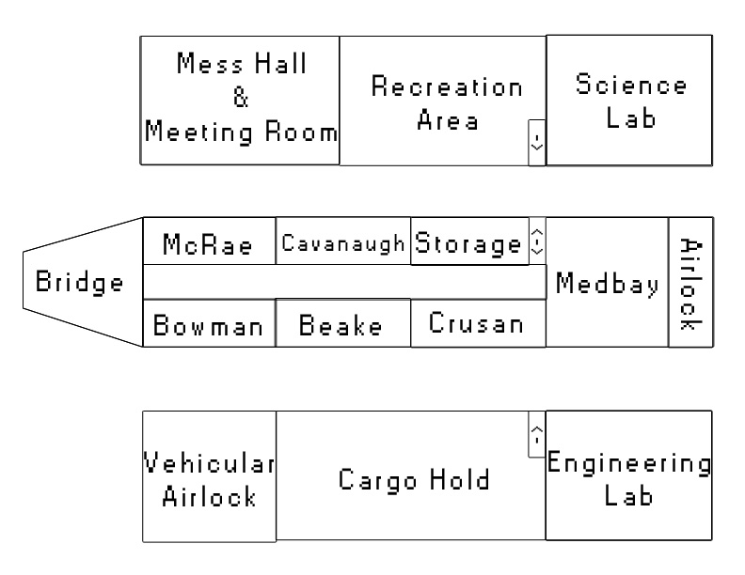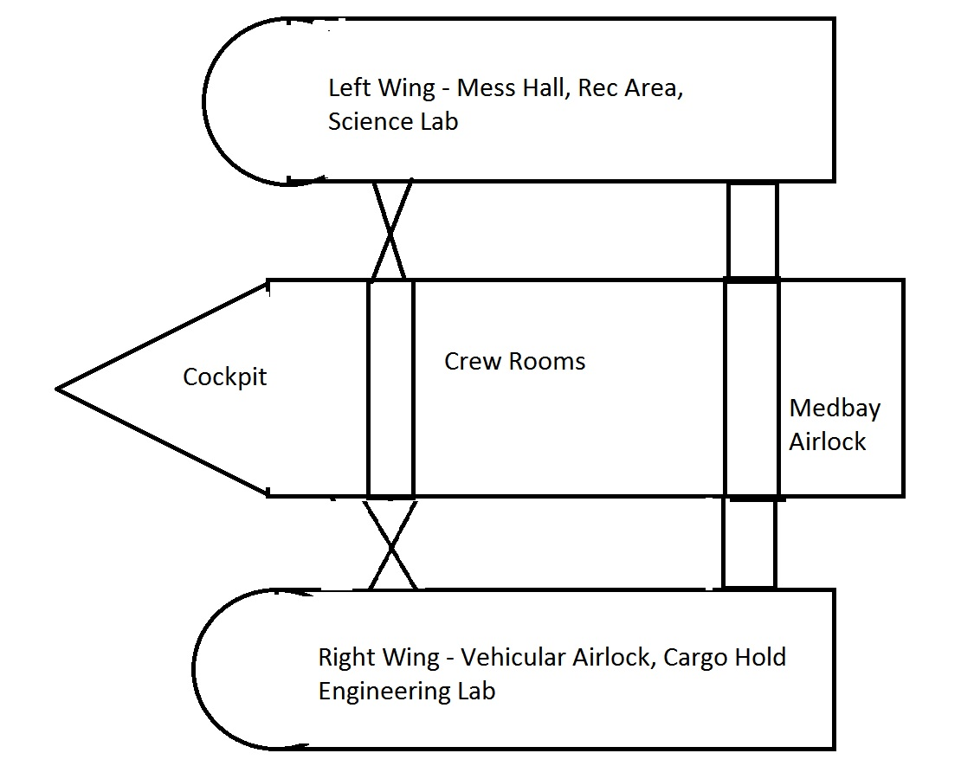

Art Style / Aesthetics
The spaceship the player explores will give off a hospital feel - clean and white - with the aim of invoking discomfort. Every wall has a purpose, whether it’s simply signage or storage or complicated wires. Overall though, lighting should be fairly dim. There may be brief cutscenes on Earth and sections of the games where the player can go on a spacewalk.
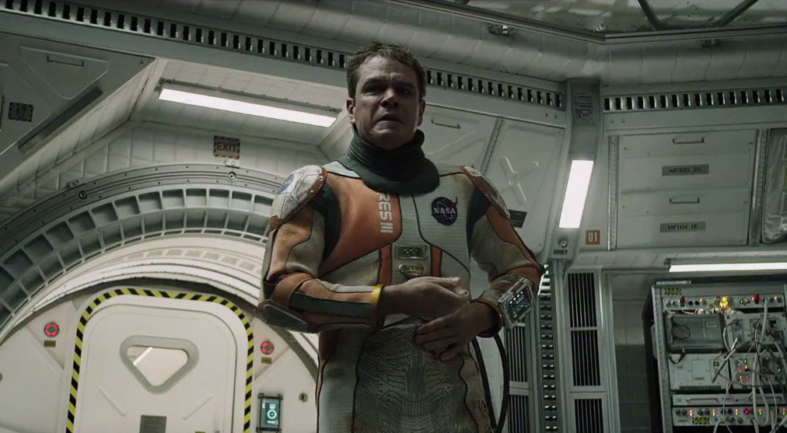
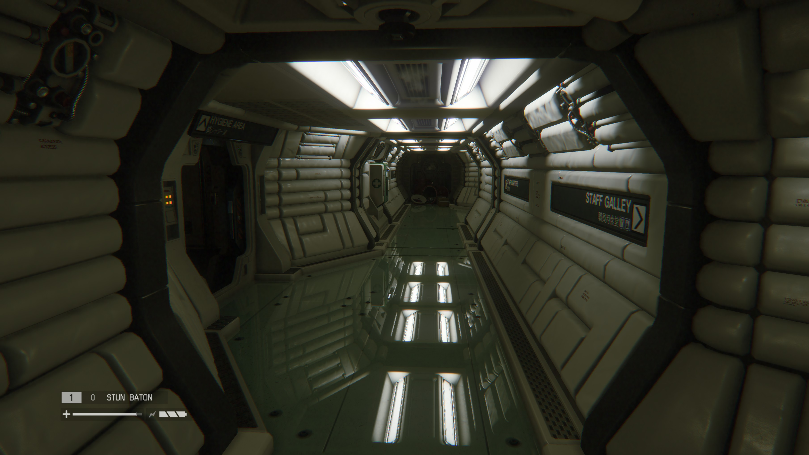
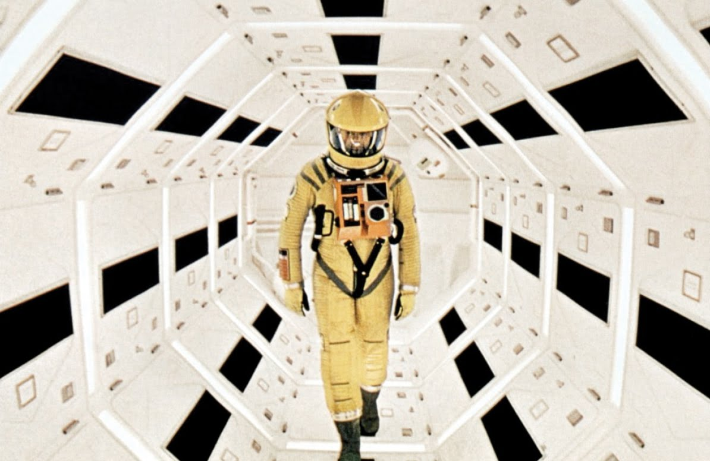
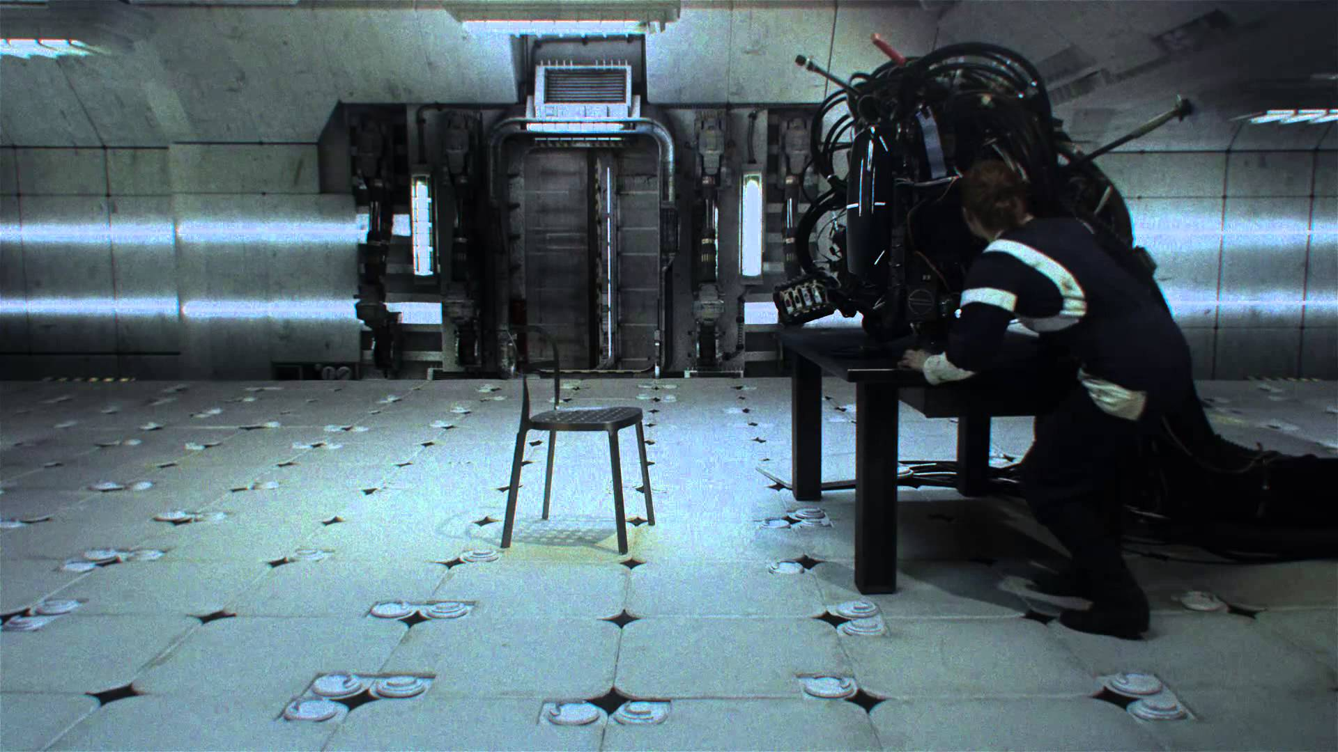
User Interface / Controls

Interface:
All HUD items will be as non-intrusive as possible. Text and icons will be displayed on a translucent white box.
Images will be at end of document.

Menus:
Through the computers, the player will be able to access the mission plan - a basic summary of the mission, information about the ship’s systems, the ship’s log, the crew’s log when at their respective computers, and save either at Bowman’s computer or at the Bridge computer. A Pause menu would place the word “Pause” just above the center of the screen with a recap of the player’s current objective just below. Pictures on final page.

Messaging:
Bowman often talks to himself about what he needs to do or what’s going on, which appears as text at the bottom of the screen. While this serves as a sort of hint system, it all makes the player wonder if Bowman is lonely or crazy.
HUD:

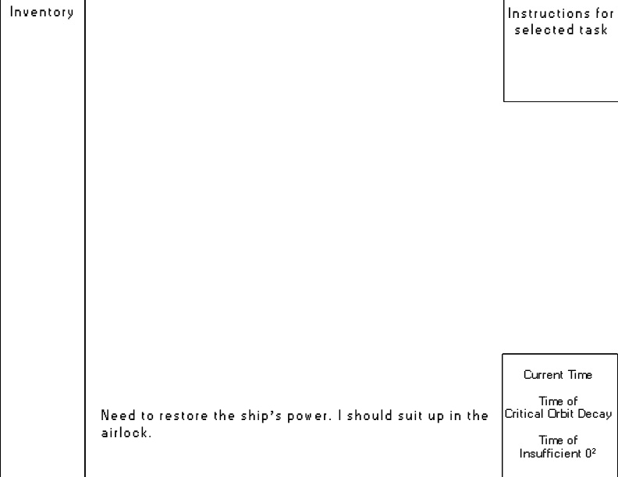
Music and Sound Effects

Music:
Music will primarily be slow, soft ambiences. Nothing fast-paced. There will be a couple of creepy ambiences for scenes with hallucinations and something special for the spacewalks. Silence is also a valuable asset. The music shouldn’t be something constant. It could also have abrupt stops and starts or something similar in order to communicate a fractured feeling.

Sound Effects:
The process of fixing the ship will result in a variety of sounds, from clanks of machinery starting up to the sound of a ratchet being turned. There should also be ambient sounds not caused by the player - the ship groaning or electrical buzzing, for example. Once the engines are on, there should be a low, constant hum in the background. Fixing the comms system will cause bursts of static occasionally but will also allow the player to communicate with Ground Control (receive hints). Fixing the life support system will result in a sudden hiss of air as the system begins renewing it. There will also be air-hiss sounds when using the airlock. Moving boxes and other objects could result in sliding or grinding sounds. Occasionally, as he works, Bowman may grunt, sigh or grumble - general sounds of exhaustion, exasperation or effort. The player may also hear sounds of objects in space hitting the hull of the ship, as it was a flurry of debris that caused the ship’s systems to be so drastically damaged. Finally, ideally, if the player manages to rescue the crew, there’d be some voice over. Having gone the entire game in relative silence, it should be almost startling for the player to hear voices.

Miscellaneous & Additional Pictures

Bridge Computer Layout xxx = placeholder
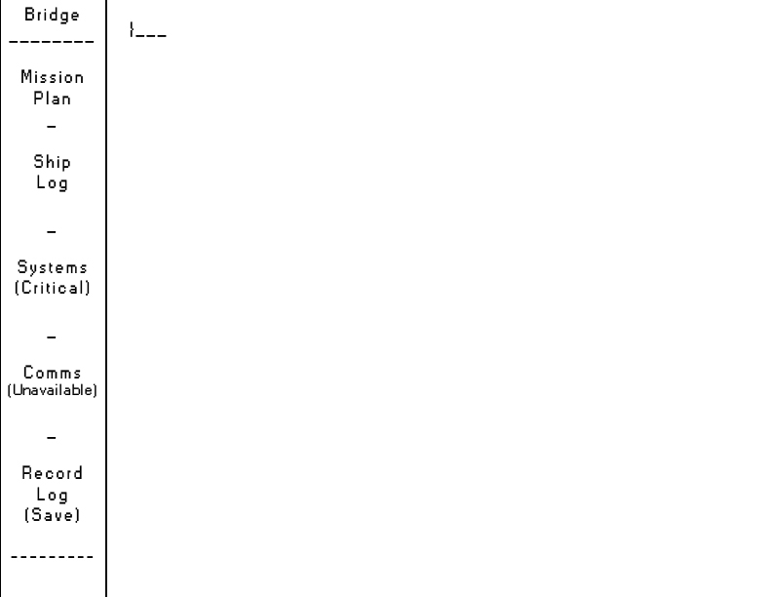

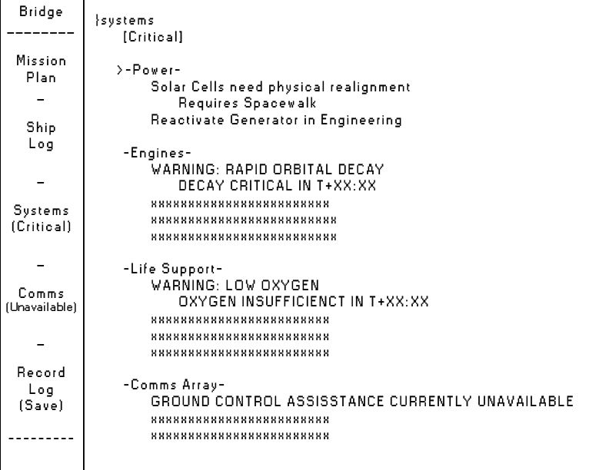

Personal Log Entry Layout
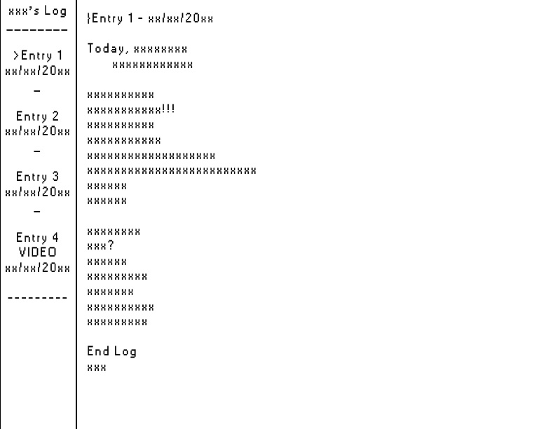

Cinematic #1 - Opening
Establishes location, player objectives and urgency
Placement In Game: Follows Title Screen after “New Game” or similar has been selected

FADE IN:
The Janus spaceship, drifting slowly in orbit around Europa, a big icy ball in space. Past Europa, Jupiter and the Red Eye can be seen. Should introduce a peaceful feeling.
Text in bottom left:
The Janus
In Orbit of Europa

Some debris, meteorites, rocks or some such, is briefly seen moving in quickly towards the spaceship.

CUT TO:
USAF Major Tom Bowman seated at a desk in his small, tidy room aboard the Janus. He’s typing at his computer. He begins reading his letter out to himself, carefully spellchecking.

BOWMAN:
“Lorraine, I’m happy to tell you that we’ve reached Europa without any major problems. I’ll take some pictures for you. Commander McRae claimed we’d overshot our target and were headed straight past Europa towards Jupiter. Gave the crew quite a scare. It’s unprofessional but I feel it’s not my place to call him out on it. At least, for now. In general though, they weren’t too happy with him, especially Dr. Crusan. I wouldn’t want to be him right now, stuck there in ---“

At this moment, the ship is struck by the debris seen earlier. Bowman is knocked from his seat, hitting his head on the edge of the table. Alarms begin blaring on the ship and an automated voice begins to repeat the phrase “Emergency. Please report to the Bridge.” Bowman struggles to his feet. Hand to his head, he stumbles out of his room and down the hall to the Bridge. Bowman reaches the Bridge Computer.

BOWMAN:
That’s enough of that noise. I’m here now.
Presses a button next to the computer. The alarms shut off, one by one.

BOWMAN:
What the hell happened?
Bowman begins typing at the computer and navigates to the Ship’s Systems menu.

BOWMAN:
You’re gonna scream at me about something being wrong and you don’t even know what? Fine, I’ll run a full diagnostic.
Bowman begins to type again but receives an error message.

BOWMAN:
“Insufficient power to fully test all systems?” Test them one at a time! Who designed this?
Bowman sighs and navigates to a different menu.

BOWMAN:
Fine. What’s wrong with the power?
Hmmm…
Disconnected? How the hell did that happen? Damn it, that’s going to need a spacewalk to fix.
Bowman sighs again and shuts down the computer. He turns around, putting his hand gingerly to his head again and winces as he touches what’s slowly becoming a nasty bruise. He sees a shadow down the hall and freezes.

BOWMAN:
What…? But that can’t be right. No.
…
It’s nothing.
Bowman shakes his head, double checks the computer quickly and heads down the hall towards the Medbay and Airlock.

Cinematic - Beake’s Goodbye
Establishes deeper character for Will Beake and aims to endear him to the player
Placement In Game: This plays after the player has read through the files on Beake’s computer

FADE IN:
A suburban backyard. There’s one of those playplaces with a slide and swing. There’s a dog, possibly a Labrador, chasing a tennis ball. Two children, a boy and a girl, are playing with the dog. Will Beake enters the backyard from the house, small suitcase in hand.

BEAKE:
Kids…Hey…Um…Alex? Annie? It’s time for me to go.
The kids turn to look at their father, the simple pleasure of playing with a dog changing to a mix of pride and sadness.
ANNIE:
Are you sure?

BEAKE:
*laughs* Yes, sweetie, I’m sure.
Annie solemnly nods and hugs her dad’s leg. Will awkwardly pats her head.
ALEX:
HEY DAD, LOOK WHAT I CAN DO!
Alex promptly sprints to the slide and runs up without touching the sides. He turns around expectantly.

BEAKE:
That’s, uh, great, son. Try to be a little gentler with that thing, huh? I want it to still be here when I get back! Come over here, give me a hug.
Alex, a little downtrodden, trudges over and hugs his dad’s other leg. Beake kneels, holding his kids shoulders.
BEAKE:
Alright guys, I want you to be good, okay? Do what your mom says. Watch out for Sparky. Take care of each other. OH! To thine own self be true! *laughs*
Annie and Alex look confused.
ANNIE:
Daddy, what does that mean?

BEAKE:
Eh, a bit young for Shakespeare. It means don’t pretend to be someone you aren’t. Don’t let people push you around.

ANNIE:
But, I like playing pretend.

BEAKE:
*sighs* Okay. Never mind. Let’s see, how old will you two be when I get back. Annie, you’ll be…hm…twelve. And Alex - Alex, what’s wrong?

Alex has started silently crying but he’s doing his best to keep his composure.
ALEX:
I...I don’t understand why you have to go. I read that they can see Europe with a telescope! Why do you have to go if they already know it’s there?
BEAKE:
Well, they want to see if they can send someone to Europa and they need me to see if there’s life there. I’ll be looking for things like bugs, but smaller. Germs, sort of.
Alex nods solemnly.
BEAKE:
So, Alex…you’ll be fifteen. You’ll start learning how to drive. I’ll be back in time to help with that, okay? And you two can always ask you mom to help you write me emails or send videos, okay? I’ll answer as often as I can.
The two kids are both crying now. Beake is doing his best to keep his composure. He hugs them close.

BEAKE:
I love you both so, so much.
…
Alright, now, I need to talk to mom.
A woman enters the backyard. She’s been watching from the doorway. She’s a little teary-eyed as well.

SARAH:
Alright guys, go inside and play.
The kids wipe their eyes and quietly walk inside. Annie runs back out and gives Will a quick peck on the cheek.

BEAKE:
So, uh…
Sarah shakes her head, gives him a kiss and then hugs him.

SARAH:
I swear to god, if you don’t come back safe…
They embrace quietly for a moment. The dog, Sparky, walks over and sits by Will’s feet. Will bends down and scratches the dog’s head.
BEAKE:
I don’t imagine you’ll still be here by the time I get back, so this is the most heartfelt goodbye I’ll be giving today.
Sarah scoffs and shakes her head, storming back inside.

BEAKE:
*laughing* Honey? Sarah, come on!
Beake follows her inside, grabbing his suitcase on the way.

FADE OUT

Cinematic - What Happened to Tom’s Squad?
This cinematic will play after the player has fully restored all ship functions. It fully reveals exactly what happened to Bowman while he was a Combat Control Specialist and why he feels so guilty over it.
Placement in Game: Immediately after Bowman/the player fully restores all ship functions.
The scene opens on Bowman crouched in a bush on a hill overlooking a small shanty town. The town is a clearing in a forest that goes on for a fair distance. Mountains can be seen in the distance. It’s a fairly clear day, though some clouds can also be seen in the distance. The sound of gunfire can be heard and smoke rises from the town. A small black drone can be seen circling above the town.
Bowman has a small computer that closes into what looks like a silver briefcase, like in action movies, but more tactical looking. It has a sizable dent in the back, but appears to still be working. Bowman is wearing green camo and a large headset plugged into the computer. He looks grim.

BOWMAN:
Roger that. I’m picking up heat signatures in the next building. Proceed with caution, Delta.

Faintly, from the headphones, an angry, impatient voice can be heard shouting.
The man is Rick Piper, a rough customer who’s seen more than his fair share of firefights. He lives for excitement and his little tolerance for bureacracy, indecision or inexperience.
DELTA SQUAD LEADER RICK PIPER:
Let’s not worry about the next goddamn building until we’re in there, understand? Pull your head out of your ass, Major. Take a breather, men.

Bowman, visibily irritated, remains silent for a moment.

BOWMAN:
There appear to be civilians in there with armed combatants. It doesn’t look like they’re being held hostage. I’d suggest starting with gas.

RICK PIPER:
Blow that gas out your ass, Bowman. Heh. Gas in your ass.

Laughter can be heard over the headphones. Apparently, the whole squad thought it was funny. Bowman looks angry for a moment and then acquiesces, cracking a smirk.
The computer begins to beep urgently. The smirk falls from Bowman’s face.

BOWMAN:
Delta, I’m getting a large mass of incoming signatures approaching from the north.

RICK PIPER:
Damn, musta heard us. Ready up, boys. We got Charlie incoming.

BOWMAN:
Signatures coming in from the south now. Delta, you’ve got to get out of there.

RICK PIPER:
And where in the hell do you suggest be go, Bowman?

Bowman types furiously at the computer.

RICK PIPER:
BOWMAN. I need an answer NOW!

BOWMAN:
Damn. Uh, retreat?

Momentary silence. Bowman can hear the gunfire start up again.
RICK PIPER:
Retreat? Are you out of your goddamned mind?

BOWMAN:
It’s the best thing to do. There shouldn’t be anyone behind you. Just GO dammit.

RICK PIPER:
To his squad.
MOVE BACK. Get to cover, goddamnit.
To Bowman.
Shouldn’t be? What in the hell do you mean by that?

BOWMAN:
Almost guiltily.
I haven’t scanned it in about twenty minutes now.
More to himself than to Piper.
It wasn’t practical.

RICK PIPER:
Sunuvabitch. RETREAT. We’re heading back. GET THAT DOOR OPEN. If I get out of this, Bowman, I’m coming for your a-aaarghSHIT. Damn trap.
Shouting in a strange language can be heard.

RICK PIPER:
I don’t think so, you bastards.
Loud gunfire and shouting is heard through the headset, a loud thud and then silence.
Bowman waits, the color completely drained from his face.
The rustling sound is heard followed by, very clearly, a stranger speaking a foreign language directly into the microphone, followed by laughter.
Screams can now be heard, both over the headphones and faintly from the distance. Delta Squad is being slaughtered.
Bowman shakes himself, packs up his computer and stands. After looking at the shanty town for a moment, he turns and jogs off into the forest, away from the town.

Back onboard the JANUS, Bowman is seen sitting against the wall outside his room. He sighs, picks himself up and frowns. He squares himself up and starts walking towards the Bridge.

Cinematic - Daring Heroics
Bowman has just docked the JANUS Lander with the JANUS through the use of the docking arm and a brief but tense spacewalk. Bowman is reunited with the crew and his worries are gone.
Placement in game: This takes place after the player has solved the trajectory puzzle at the Bridge computer and redocked the JANUS Lander.

Bowman is typing at the computer in the Vehicular Airlock, waiting for the crew to finish docking procedures. He’s a bit sweaty and a bit shaky, but he seems generally relieved.
Two loud knocks come from the door to the Lander.
Without looking up from the computer,
BOWMAN:
Who’s there?

Muffled, from inside the Lander,
McRAE:
HEY, that’s my line!
CRUSAN:
Bowman, please let us out. I need to get away from him.

Bowman chuckles softly to himself and strolls over to the Lander. He places his hand on the lever that will open the door, but hesitates. To the side, he sees a grizzled man in a military uniform. This is the main form that’s been shadowing him as he repairs the ship. Bowman nods to it.

CRUSAN:
PLEASE.

Bowman pulls the lever. Crusan tumbles out, barely keeping her footing. Following right after Crusan is the smell of four unwashed bodies living in closed quarters. Bowman visibly reacts. Crusan has already disappeared, presumably heading either straight for her room or the showers.

Now stepping out of the hatch, grinning,
McRAE:
Aw, come on. It ain’t that bad. I’ve actually gotten used to it.

Following McRae is Mac, who’s laughing. A grumpy looking Beake tries to hand her some sample containers from inside the shuttle, but she’s busy stretching. Beake grumbles to himself and attempts to step out of the hatch while cradling the samples in his arms. He almost loses his balance before McRae catches him.

McRAE:
Easy there, big guy. As fond as I am of you three, I don’t wanna get back in that little pod anytime soon.

Beake glares at him and Mac for a moment, obviously holding them responsible for the near disaster. He grunts, nods to Bowman, who responds in kind, and trudges off, possibly sore from living in such a small space for a week. He might do some simple stretches as he walks away. McRae ducks back inside the Lander to make sure they got everything they needed. Mac finishes stretching and looks at Bowman.
MAC:
Yo, Tommy, what the hell happened?

Casually, playing it off,
BOWMAN:
Hm?

Coming back out of the pod, possibly with a concerned tone,
McRAE:
Dude, you weren’t responding. I even tried singing your theme song.

BOWMAN:
Oh, there was a meteor shower, did some damage, but I got it all fixed up in time. Wait, what’s my theme song?

MAC:
Shit, man. Sounds like a lot of work. Glad I was down there.

Trying to keep a straight face,
McRAE:
You know,
Ground control to Major Tom...

BOWMAN:
Christ.
Bowman immediately looks annoyed. He grunts in exasperation before sealing up the pod and leaving McRae and Mac. Mac has now joined in with McRae’s tone-deaf rendition of Space Oddity. Laughing while they sing, they begin following Bowman up towards the rest of the ship. McRae trips and falls on his face. McRae declares his pain, possibly with a wide variety of expletives, while Mac laughs. Bowman turns, looks, shakes his head and continues on.

FADE TO BLACK

