Game Design Document for:

Donegal

The Basics

Game:
In Donegal, players will take on the role of a traveling monk who comes across a village in dire straits. The player will learn of a curse upon the villagers and will take it upon themselves to help. The monk must journey through a forest and castle overtaken with the strange and arcane in order to confront an ancient evil druid.

Genre:
Donegal is a text based adventure game, with focuses on puzzle solving and non-violence.

Audience:
Players who enjoy adventure games, puzzle solving, and solving problems non-violently.

Unique Selling Point(s):
Donegal features an unusual setting for games, 19th century France in a world where the fantastic and magic of myth and legend were real, with plenty to explore. Players must work through the challenges they will face peacefully, and they must rely on their wit to do so. The format of the game, text adventure, easily allows for more paths to be developed than a player can take in one playthrough, allowing for replayability.

Story

Plot:
A tax collector from King Louis XV, arrives in the village of Donegal. The people of the village, though obviously not thrilled, quickly pay up and urge the collector to leave. Suspicious, the tax collector demands to stay the night. He is never seen again. The village is suspected of treachery and the King dispatches men to investigate.
A monk, Jacques Roux, arrives at the village in the late afternoon, a few days before the King’s investigators arrive. Jacques, hoping to resolve the mystery of the missing tax collector and help the villagers, searches in the village for a place to stay the night, but is gently turned away by the residents. A young girl excitedly tells Jacques of monsters that prowl the village at night, but Jacques does not believe her. Jacques continues down the road out of the village but comes across a young boy, wounded near the forest. Jacques returns to the village with the boy, seeking medical aid. The people are shocked he has returned and as the sun sets, they turn into monstrous animals and attack. Jacques must take the boy and find somewhere to hide in the village until morning, using his memory of the village to trick the monsters and find a place to hide.
When morning comes, the people transform back. They tend to the boy and beg for forgiveness. Jacques is understanding though curious. They explain their curse, the death of the tax collector at their transformed hands, of Emile de Delacroix and his castle on a ridge above and beyond the forest. Jacques promises to help, though he must do so before sundown, because the injured boy will have to stay in the village.
He sets off through the forest, making his way through the Shepard’s Walk, where the trees move and the path is ever changing, and the Garden of Screams, where the plants make terrible sounds and drive travelers mad. Jacques comes across ancient Pagan Ruins deep within the forest, an ancient burial site long taken by time. No one had been there in centuries. As Jacques makes his way through, he learns of the heartless Bricius Dannotalos, an elder druid of the Gualian god Cernunnos, and the uprising of the local tribes. Jacques also finds the ceremonial dagger Bricius used for his ritual sacrifices. If the player has a maxed out Unusual score in their PLUCK skills, ghosts will appear to Jacques in the Thorn Grave and explain what is going on with Bricius, Emile de Delacroix, and the village.
When Jacques reaches the castle, he makes his way through the Crumbled Courtyard and the Halls, learning of Emile de Delacroix and his Bricius-driven descent into madness. The castle is overrun with the arcane wild, and Jacques must carefully navigate the maze of halls to the Throne Room.
Jacques confronts the body of the long dead Emile de Delacroix, possessed by the longer dead Bricius Dannotalos. Jacques makes a plea for the village’s sake. Depending on what he has learned and his PLUCK score, Jacques may be successful, either cutting a deal or convincing Bricius to move on, though it is distasteful to Jacques to make a deal with Bricius. If speech fails, Bricius attacks. Jacques can exorcise Bricius from Emile or, if he met with the ghosts in Thorn Grave, he can confront Bricius with the ceremonial dagger, through which the ghosts come to exact their own vengeance. Through any of these paths, Bricius is dealt with and Jacques returns to the village as the sun is setting.
Jacques arrives just after night and the people are supremely relieved to find themselves human. They thank Jacques and offer him rewards, though he requests only to stay a night or two. Jacques asks the villagers how they plan to deal with the King’s investigators. They have covered their tracks in regards to the tax collector’s death, and can only hope the investigators come to the conclusion that the collector took the money and ran.

The Player Character:
Jacques Roux was raised in a monastery from a child. He has a deep sense of right and wrong and he abhors violence. Jacques would frequently travel outside the monastery to help people against his Abbot’s wishes and it came to a head when Jacques stood up to a local tax collector who was bullying people out of their money. The tax collector made frequent and large donations to the monastery, of which the Abbot was very appreciative. Jacques was exiled in order to ensure the future financial solidarity of the monastery. Jacques travels around, wishing only to help people, and he hopes to find a place to settle down where he can do good and spread his ideals for a long time. In Donegal, Jacques is shocked and saddened by the curse of the townspeople and wishes to release them from their curse.

The Foe (Shadow):
Bricius Dannotalos is an evil man who enjoys the suffering of others. Once an elder druid of the Gaulish god Cernunnos, Bricius believes nature is all. He frequently sacrificed members of dependent tribes in order to appease Cernunnos, who protected his tribe. Bricius was slain during an uprising of the dependents, though invoked the rancor of Cerunnos as he died to slay those who killed him. Bricius, having failed to kill all of the rebels, tethered his spirit to the forest to complete his vengeance. Centuries of seething means he is no longer interested in eliminating the descendants of those who murdered him, but rather causing them unending torment. Eventually Emile de Delacroix decided to build a castle in Bricius’ forest. Bricius drove the young lord mad and possessed him, granting him greater power and a stronger hold on the world around him. Bricius wishes only to cause pain and suffering to people, claiming he’s doing it for Cernunnos. He uses arcane and eldritch powers to manipulate nature.

Other Characters:
Gabriel Dubois – An adolescent boy and apprentice trader who was traveling through the forest with his master and a wagon of goods. They were ambushed by the monsters lurking in the forest, who killed the trader and left Gabriel for dead. He is found by Jacques and taken back to the village to receive aid—only for the villager’s curse to be revealed. Gabriel is a quiet and studious boy. Though injured and feverish, he nevertheless is grateful to Jacques for protecting him and admires the former monk’s selflessness.

Hubert Sauveterre – A heavyset man who runs the village’s local tavern and former inn. Despite his gruff appearance he is the shoulder on which the villagers lean for support. He regrets turning away travelers, especially knowing the dangers beyond their village. When night falls he takes on the therianthropic form of a bear.

Armand Mercier – - A scrawny, but clean shaven, merchant who manages the supplies scavenged from caravans that are lost in the forest. He always has a kind word for travelers and gives them supplies for free to encourage their swift departure. When night falls he takes on the therianthropic form of a hawk.

Helene Villeneuve – A tall and fair woman with medical knowledge who provides care for the villagers injured normally and after any incidents occur during the night, as well as for travelers if aiding them will help them leave the village before dark. She treats Gabriel during the time when Jacques goes to stop Bricius. When night falls she takes on the therianthropic form of a deer.

Bertrand Favager – The well-muscled blacksmith who manages the village forge. He built and maintains the fortifications surrounding the village. He is quick to provide weapons to travelers to try and ensure their safety. When night falls he takes on the therianthropic form of a wolf.

Yvonne Bellerose – A young girl with a sunny disposition despite the gloomy atmosphere that blankets the village. She loves meeting travelers, though has a tendency to unsettle those that pass through with vivid stories of monsters in the village.When night falls she takes on the therianthropic form of a fox.

Spirits of Thorn Grave – The spirits are ancient Guals, members of Bricius’ tribe and others, those who were sacrificed and those who died in the uprising. They are tied to the land by the same spell that keeps Bricius there and they wish to move on.

The villagers are kind and helpful, if worried, and they try to keep travelers away from the village at night. Those who have left the village in an attempt to escape the curse continued to change at night. It’s best for everyone’s safety if they remain together in the village, to not spread word of who they are.

Story Vehicles:
The story is delivered through the people Jacques meets, words left behind in notes, diaries, and journals that Jacques finds in the game, and Jacques’ own observations.

Gameplay

Player Experience:
This is a puzzle game, so the aim is to challenge player to picture the situation, think about it, and choose what they think is the best option. There will be no instant death for picking the wrong option, but there is a small pool of health that may take a hit, or future puzzles might change. The aim is not to unduly frustrate the player, but make them feel challenged. When they overcome the challenge, they should feel good about thinking their way out. If they got hurt, hopefully, they’ll consider more carefully in the future.

Player Character Actions:
When opposition arises to Jacques, the player will be presented with choices, typically two to four. There will not always be one best option; sometimes two are good and sometimes only one will be bad. When interacting with other characters, the player will be given a choice of dialog, though not as many as four all the time.

Player Character End Goal:
Jacques aims to end the curse of the villagers before sundown. There are a few different ways to approach the ending but ultimately, the same general things will happen. Bricius will be dealt with, the villagers will stop transforming into vicious monsters, the boy will stay in the village, and Jacques requests only to stay a night or two before moving on.

Enemies:
Enemies include the transformed villagers, the walking trees of the Shepard’s Walk, the moaning, bleeding trees of the Garden of Screams, and Bricius. The villagers are not in control of their transformed selves. They simply wish to kill. The walking trees have no aim; they simply wander, changing the path through the forest. The moaning, bleeding trees aim to drive travelers mad, so the bodies can be incorporated into the forest and it may grow. Bricius is the cause of this arcane forest and curse and he aims only to make people suffer.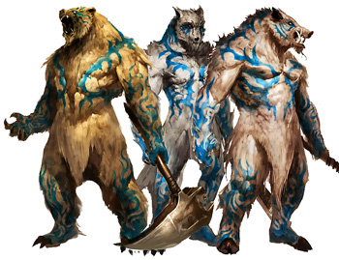 Therianthropic Monsters - each monster’s build would be more appropriate for who they are as a human and they would not carry weapons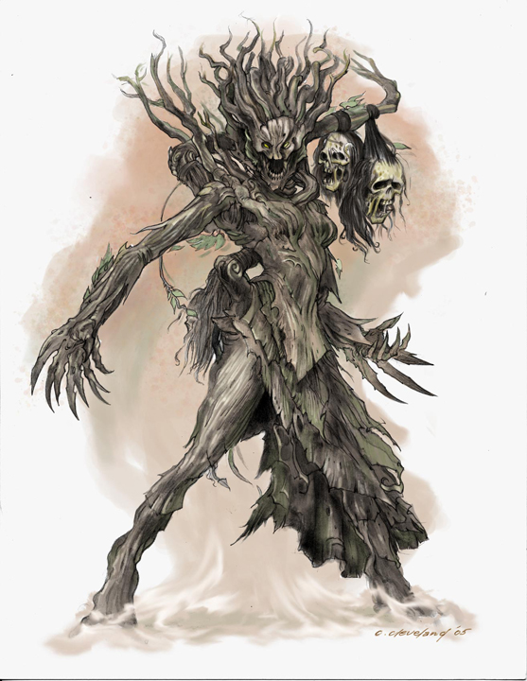
Concept for Bleeding Trees – they are undetectable when they hide as regular trees

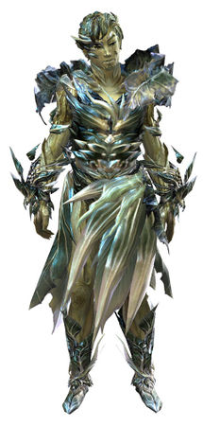 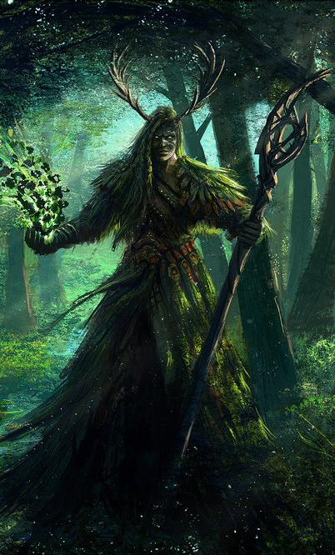Concepts for Bricius

Combat:
No combat. The player must think their way through each situation and avoid threats as much as possible.

Obstacles:
Puzzle solving extends to the locations in the game as well as encounters. The player will get the chance to explore the village and will have to remember what they saw in order to hide and evade the therianthopic villagers. They will have to navigate through the forest and the halls of the castle using hints and clues, similar to the navigation puzzles in the Legend of Zelda games.
Examples:
- Village
  - The player will have to remember the village areas from their earlier exploration. They will have some sort of encounter with each of the therianthropic villagers, which they will have to overcome primarily by using the environment around them, working on a case by case basis. The Cunning, Luck, and Perception skills will help here.
- Forest: Shepard’s Walk
  - Much like the Lost Woods in many Legend of Zelda games, the player will receive hints through either text or audio cues as to which direction they should go. Getting “lost” and choosing the wrong direction will send the player to the beginning of the Shepard’s Walk. There will be between 5-10 rooms of this. The Perception trait will help here.
- Forest: Garden of Screams
  - This is a movement based puzzle with cues given through text and possibly audio. If the player moves when it is not “safe,” they will be attacked by the Bleeding Trees, who see based on movement or sound. The Cunning, Luck, and Perception traits will help in this area.
- Castle: Halls
  - This area works as a combination of the Shepard’s Walk and Garden of Screams areas, though players will not be restarted for choosing to explore and going the “wrong” direction. The Bleeding Trees are also in this area, though not as intensely as in the Garden of Screams. Players will be presented a mix of the earlier text and/or audio cues in this area. The Cunning, Luck, and Perception traits will help in this area.

PLUCK:
Players will select three PLUCK traits at the beginning of the game. These traits will affect events in the game primarily by unlocking an extra choice for the player to explore, related to each attribute, allowing the player to learn more about their environments or more easily avoid obstacles. PLUCK stands for Perception, Luck, Unusual, Cunning, and Kindness. Perception would allow the player to learn more about their surroundings as well as occasionally giving the player an extra option during encounters/puzzles. Kindness gives the player different options when interacting with other characters. Luck and Cunning will affect how the player interacts and approaches obstacles in game. Unusual will allow the player a better understanding of the strange things going on in the forest and will allow the player to communicate directly with the Spirits of Thorn Grave.

Replayability:
The player will have several options and paths to take throughout the game, including taking different PLUCK traits, but they all ultimately lead to Bricius. The player will also have a range of choices with how to deal with him that will affect the ending, though in small ways.

The Game World

Environments:
- Village
  - Inn/Tavern
  - Physician’s Residence
  - Local Store
  - Blacksmith
  - Town Square
  - Homes
- Forest
  - Winding Path
  - Shepard’s Walk
  - Garden of Screams
- Ruins
  - Ruins
  - Sacrifice Chamber
  - Thorn Grave
- Castle
  - Crumbled Courtyard
  - Halls
  - Throne Room

Interactivity:
The player will generally be able to examine or examine closely if they have the Perception skill, which would reveal more detail, and other contextual actions, which would foreseeably be openly presented. For example, the Sacrifice Chamber might give the options:
- Examine
  - Table
  - Room
  - Knife
- Lay on Table
- Leave
When the player examines the table with the perception skill, they’d be presented with further options such as Examine Runes or Examine Blood Stains. Examining the knife would work the same, as well as give the player the option to take it.

Key Locations:
Vital parts of the story occur in
Village: Town Square – overrun by a huge tree, with a small stream that runs through
Ruins: Sacrifice Chamber – claustrophobic, dank, earthy, and dominated by a large stone table
Ruins: Thorn Grave – a graveyard behind the ruins covered in brambles and an eerie glow
Castle: Throne Room - An ostensibly tall room that looks like a ribcage made out of tree roots. The throne is made of thorns and resembles a heart a great beating noise is made when Emile de Delacroix’s body creaks its way out of the throne.

Game Flow:
Story Order is:
- Winding Path, which runs through the village
- Village
  - The player freely explores until they are ready to leave
- Winding Path, on the other side of the village, into the forest
- Village
  - The player returns with the injured boy and searches for a place to hide
- Village: Town Square
  - Jacques promises to help the townspeople
- Forest: Winding Path
- Forest: Shepard’s Walk
- Ruins
  - Ruins areas can be explored in any order
    - Ruins: Ruins
    - Ruins: Sacrifice Chamber
    - Ruins: Thorn Grave
- Forest: Garden of Screams
- Castle: Crumbled Courtyard
- Castle: Halls
- Castle: Throne
- Village: Town Square
  - It seems cruel to force the player to walk all the way back themselves, so it’ll be a jump to with a short description of how the forest has changed after Bricius is gone, with respect to how the player dealt with him.

Map/Layout: