Game Design Document for:

Aspect – Working Title

The Basics

Game:
On a space station orbiting Enceladus, an elite team of scientists are researching a dimensional tear when things go horribly wrong. A terrifying creature manifests itself through the tear and begins to wreak havoc on the station, threatening to tear open a hole in the universe itself. Players must use the dimensional tear to travel through the 8th dimension and destroy the creature.

Genre:
A 2D Sidescrolling Horror Puzzle game, similar to Detention, Claire, and Bioshock.

Audience:
Fans of puzzle games, horror, and science fiction

Unique Selling Point(s):
- Pseudo-Horror elements
- Focus on Puzzle/Problem Solving
- 8th Dimension and Mechanics based off actual scientific theories
- Consistent but not perpetual dark sci-fi/space atmosphere & aesthetics
- Manipulation of Physics and Thermodynamics by visiting other Universes via 8th Dimensional travel
  - i.e. move to a Universe with lighter gravity to move heavy boxes
- Monster freely moves between rooms as they are rotated
- Escalating access to chambers on the station and manipulatable physics

Story

Plot:
The player is the lead engineer on a rescue mission to the ISA Aspect, a research station studying a dimensional tear near Enceladus. The station had sent out a distress call shortly before going quiet. The player has been sent with a small crew to investigate and learns the original research team, now missing, found a way to enter the dimensional tear, which leads to the 8th Dimension, a way to travel between similar universes with different physics.

The player goes about restoring the station to working order while searching for the original crew. Along the way, the player receives an upgrade for their data pad that allows them to travel through the 8th Dimension. Shortly afterwards, the creature from the 8th Dimension begins to manifest onboard the Aspect and attack the player.

The player must use the physics of the different universes to restore the Aspect to working order and find a way to banish the creature. As the player travels between universes, they find the broken bodies of various scientists, not always from the right universe.

Towards the end of the game, when the Aspect is nearly back in working order, the player’s crew is abducted. The player confronts the monster and uses 8th Dimensional travel to weaken it. For a moment, the player is given a glimpse of themselves inside the monster’s form. It is revealed that the monster was the player character attempting to stop the destruction of the universe. The power of this fight causes the lines between universes to fully break down, and as the player character is tossed between universes, they use 8th dimensional travel to reverse the flow of time. They arrive back on the Aspect, as the creature, just as the crisis starts. The player takes on the role of the monster and goes about destroying the Aspect. Realizing this will only continue the cycle, the player sacrifices themselves to seal the dimensional tear, preventing any further travel.

It is revealed that the earlier player character from this universe was not erased in the process, just as they arrive at the Aspect.

For the sake of scope, this is the ending we will use, though we can and do have some additional endings in mind, time permitting

The Player Character:
Character Specifics and names are still being worked on.
Designated leader and head engineer of the small crew tasked with responding to the Aspect’s distress call. Known to be pragmatic and levelheaded in tough situations, though not above a sarcastic remark in response to the antics of their crewmembers. The straight man to the quirkiness of the other characters.

The Foe (Shadow):
The creature from the 8th Dimension is a physical manifestation of the blurring lines between the universes. Each time the player character travels through the 8th Dimension to solve a puzzle, the creature grows a little stronger and the barriers between universes weaken more. The creature’s goal is to put an end to whatever is traveling through the 8th Dimension, as this threatens the barriers between universes. Contact with the creature drains the player character – if they stay in contact too long, the player character will be ‘erased’ from the universe, achieving the creature’s goal. The creature is a twisting, vaguely human-shaped, dark and hulking form. It moves slowly but is rather menacing.

Other Characters:
Character Specifics and names are still being worked on.
Mechanic Lady - The technician of the crew, who helps the player fix up the Aspect. An overly excitable woman who loves bright colors and cute things. Perpetually positive, even during tense situations. She cares deeply for her peers and—when it’s clear things are far more stressful and dangerous than any of them anticipated—wants to ensure they remain hopeful and safe.

Despite her notable skill at her job, anything she tries to build for fun seems to break.

Bag Head - The software engineer of the crew, who uploads and manages the virtual intelligence program. An oft silent man with a lot of personal trauma who copes in an unusual fashion by permanently wearing a paper bag over his head. A dedicated worker, though skittish. As the game goes on and the situation gets worse, he gets more and more anxious and terrified.

Oversees the upgrades to the player’s data-pad.

Virtual Intelligence - The virtual intelligence coded by Bag Head, meant to be uploaded to the Aspect to retrieve the data saved on the ship in the event of system failure. As it is not an AI it has no inherent sentience but can mimic human interaction… mostly. As the player repairs more and more of the spaceship, the virtual intelligence gains access to more and more systems and information that helps the player continue forward.

The Crew of the Aspect - The original team of scientists and engineers that took the Aspect out into space. As the player investigates what happened on the Aspect, they will find data-pads and logs left behind that explain how the crew was killed by the creature from the 8th Dimension.

Story Vehicles:
Story will be passed to the player primarily through dialogue with the other characters, though the player character may have some inner dialogue mainly for hints with puzzles. Additional world-building information can be found around the station on various computers and/or data pads.

The 8th Dimension:
The 8th Dimension is an actual concept in science – picture every universe in the multiverse as a point on a 2D graph with an X and Y axis. If you look at our universe and a universe identical to ours except the gravity is twice as much, in theory you can draw a straight line between our universe, 2X gravity universe, and every other universe like ours but with different gravity. That is the 7th Dimension, the X axis. If you do the same for the Y axis, say for the speed of light, and you have the X and Y axis going at the same time, that is the 8th Dimension. Players will only be able to move in the 7th Dimension initially, with 8th Dimension travel opening a bit further into the game.

Gameplay

Player Experience:
The aim is to create an uneasy atmosphere, where the player knows that the monster could be behind almost any door, though we aren’t looking to terrify the player. We want players to feel good when completing a puzzle and that they understand the science behind the story so that they aren’t lost.

Player Character Actions:
Players will be able to ‘interact’ with the other crew members to have character or world-building conversations and sometimes hints. They will also be able to ‘interact’ with some objects, either to hear a bit from the player character about the object or to work on a puzzle. The primary mechanic of the game comes through the player character’s data pad, which they can use to travel through the 8th Dimension. The data pad will be the player’s HUD, and on button-press, will open the travel menu.

Player Character End Goal:
The player’s goal is to restore the Aspect to working order and destroy the creature. As they progress through the game, their data pad will be upgraded to allow access to more universes, allowing them to solve more puzzles. At the end of the game, the player is presented with a few choices about how to resolve the plot, and they will be able to carry out these choices themselves, followed by a brief monologue/cutscene.

Enemies:
The primary enemy in the game is the creature – see The Foe under Story. There may be some smaller, similar enemies for the player to face, though certainly less powerful – offshoots of the creature left behind.

Combat:
If the player is faced with the creature, they must run or use 8th Dimensional travel to escape. Traveling in the 8th Dimension will ‘shuffle’ the creature’s location in the ship. At the confrontation with the creature at the end of the game, the player will trap the creature in a room and force it through the 8th Dimension, destroying it.

Obstacles:
When the crisis begins, the creature will have damaged or destroyed various functions of the station – power, the rotational servos, life support, communications, and engines. The player must journey around the station repairing these systems – these are the ‘puzzles’ of the game.

The Game World

Environments:
The game takes place on the space station ISA Aspect, which orbits Enceladus, a moon of Saturn. The ISA Aspect is a unique station composed of twelve chambers that the scientists live and work in. The chambers are each mounted on two adjoining revolving cylinders, six to one, which allows the scientists to navigate from chamber to chamber by revolving the halves of the station. When the player travels from universe to universe, these chambers will undergo typically subtle changes, but will reflect in some way how that universe is different.

Key Locations:
The chambers on the station are:
- Cantina – a ‘safe room’ where the rest of the crew hides
- Generator/Rotational Servos
- Comms/SysOp
- Two Labs
- Sleeping Area
- Two Engines
- Life Support
- Cargo Bay
- Mechanics Bay
- Rec/Exercise Room

Game Flow:
The player will go about fixing the station in the following order:
- Rotational Servos
- Power
- Life Support
- Engines
- Communications
The stations in other universes are nearly identical in layout, and the player may be required to take vital parts from the systems there to repair the systems on the Aspect. Traveling from the Engine Room on the home universe Aspect will land the player on the Engine Room of the Aspect in whatever target universe. Depending on that universe, those Engine parts may be completely incompatible though. Players must explore not only the Aspect, but the other universes to solve problems.

Training:
The player’s training will be repairing the Rotational Servos of the station – this keeps them confined to a small area with a simple solution and will be a good time to set up the story. The monster will not appear in this section, though a hint or two about it may be dropped.

Map/Layout:
Each half of the Aspect is designed like the cylinder in a revolver. There are six ‘chambers’ to one cylinder and each chamber matches up with another on the other side. Each half of the Aspect can spin independently of the other.

As the player spins the cylinders, they must think of where they last saw the monster, as it will freely wander between connected chambers.

This should create a claustrophobic feeling and should make the player a bit nervous when moving from chamber to chamber.

Chamber
Chamber
Chamber
Door/Airlock between Chambers
Chamber
Chamber
Chamber

Art Style / Aesthetics

We are aiming for a digitally hand-drawn, realistic, 2D style, similar to Detention (below). Characters will be puppet animated in Spriter. Atmosphere should be claustrophobic and eerie, making the player a bit nervous to explore, but not terrified. Concept Art for Aspect and other examples below.
Cantina Concept
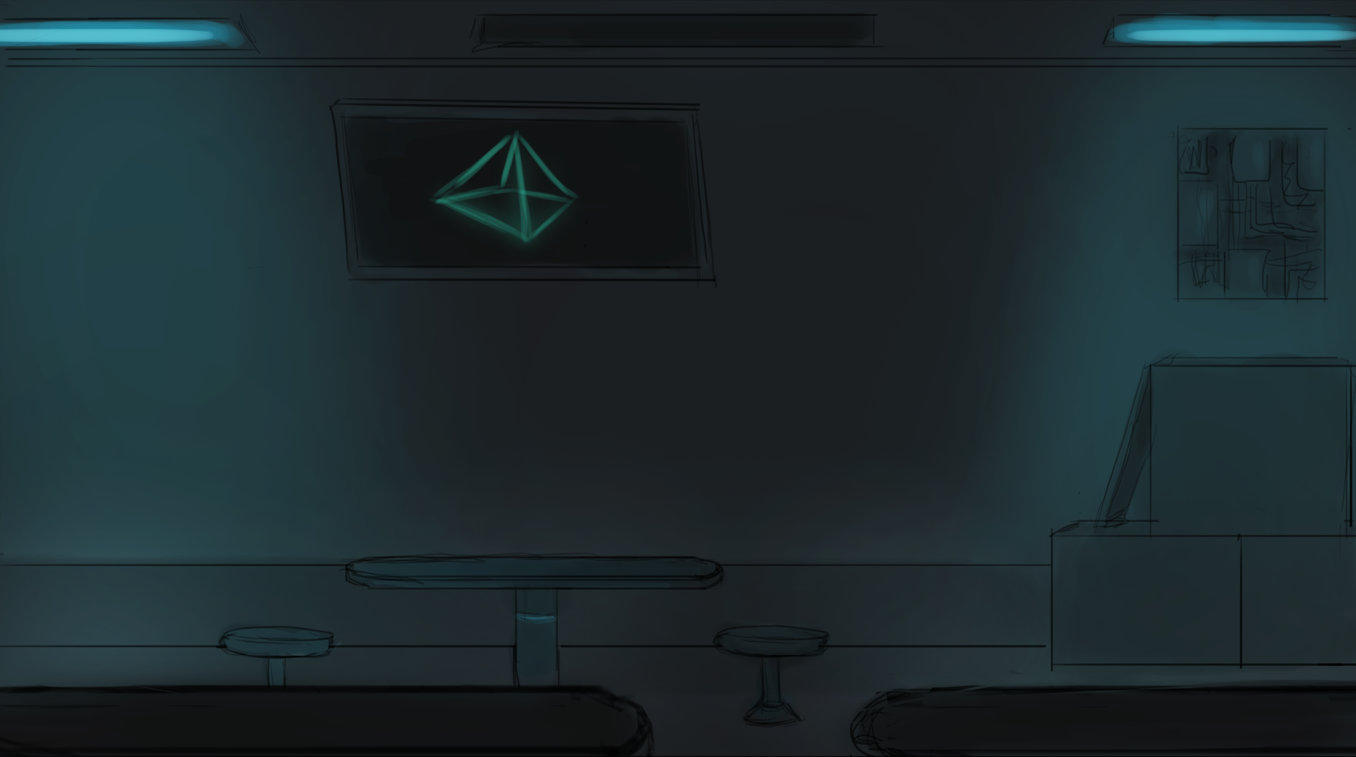

Character Concepts – Mechanic Lady and Bag Head
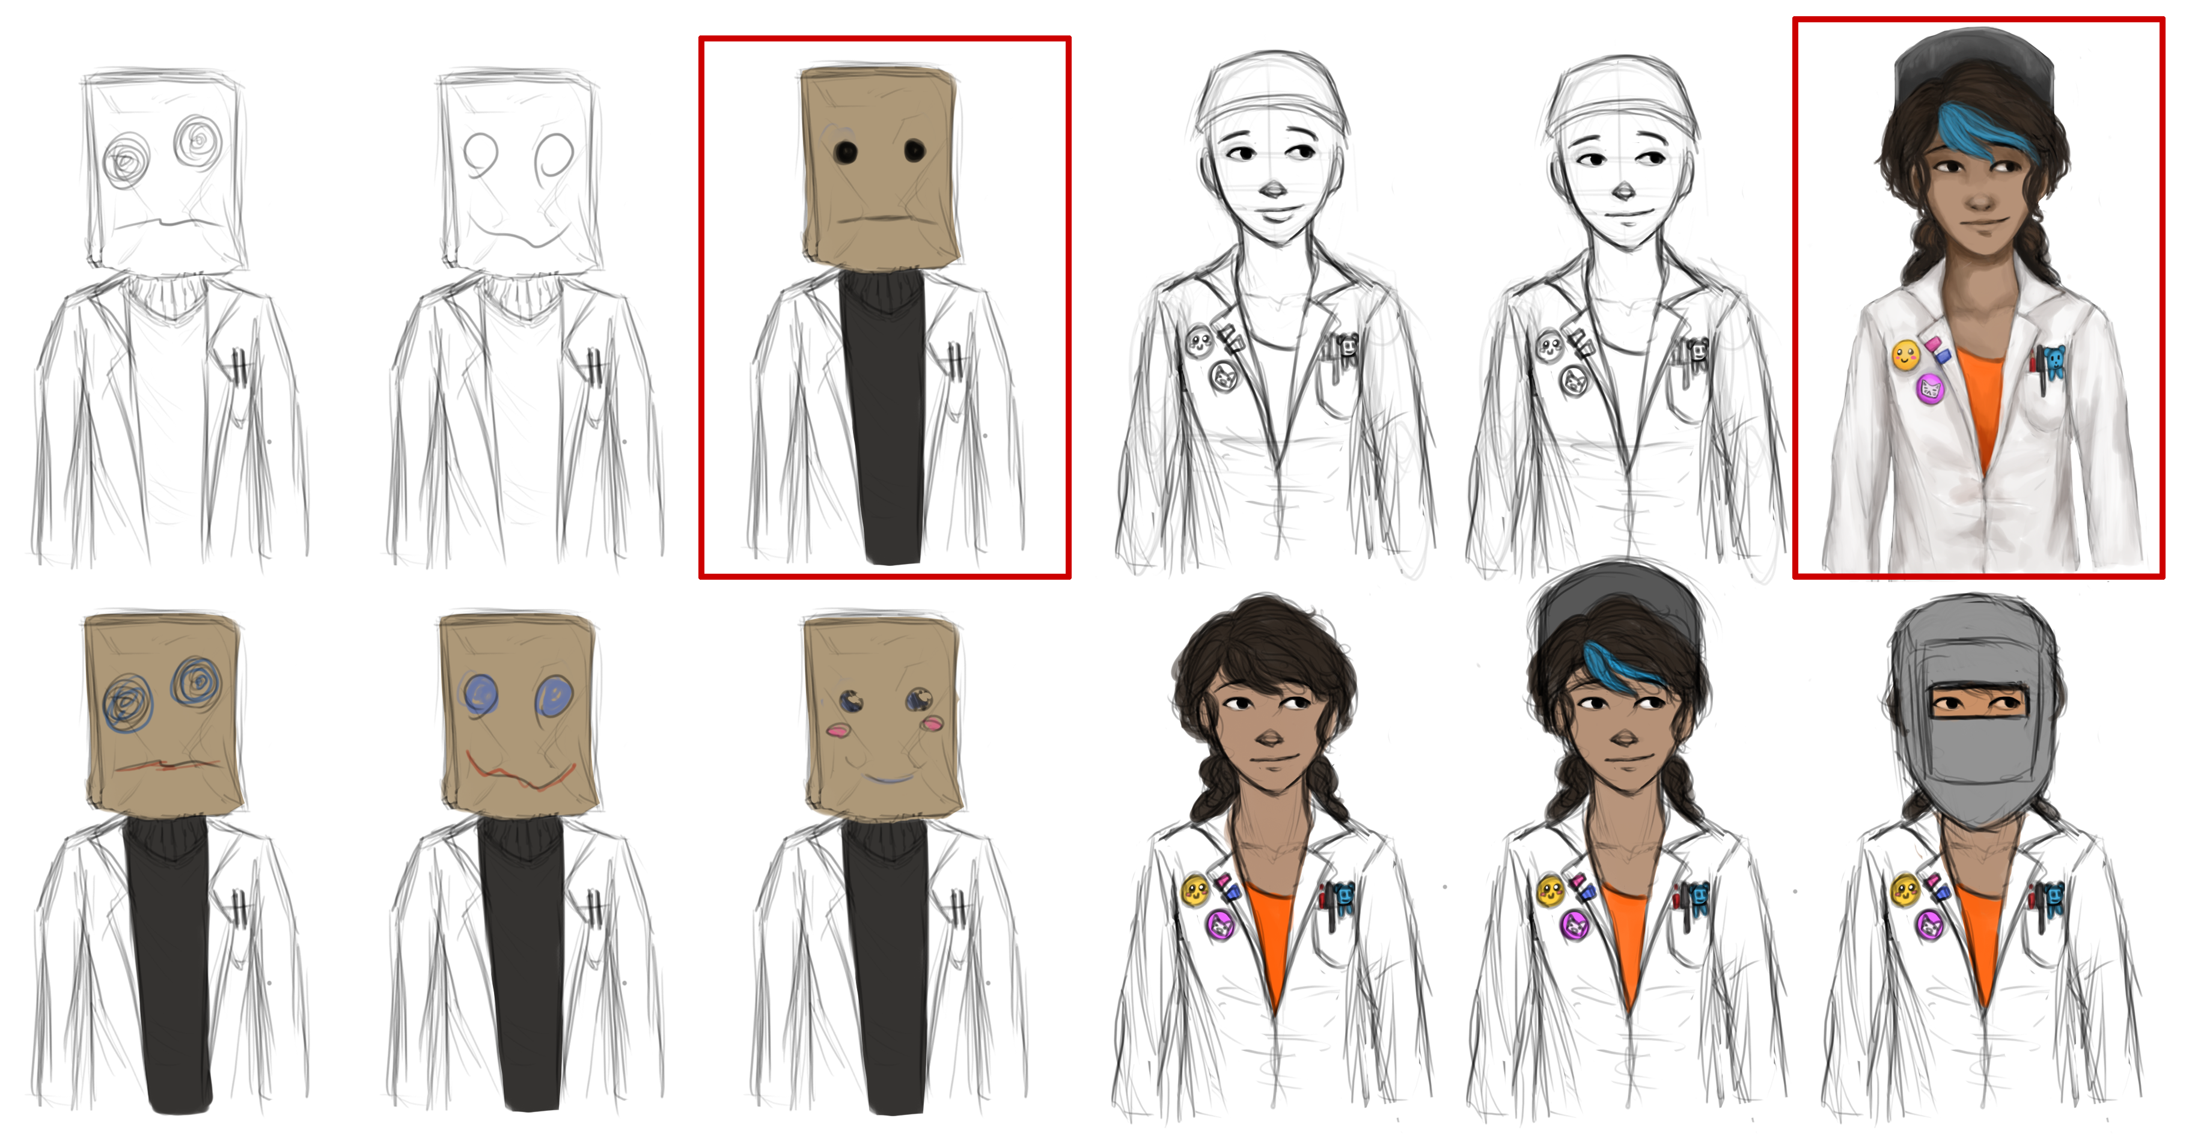

Dead Space Concept Art Example
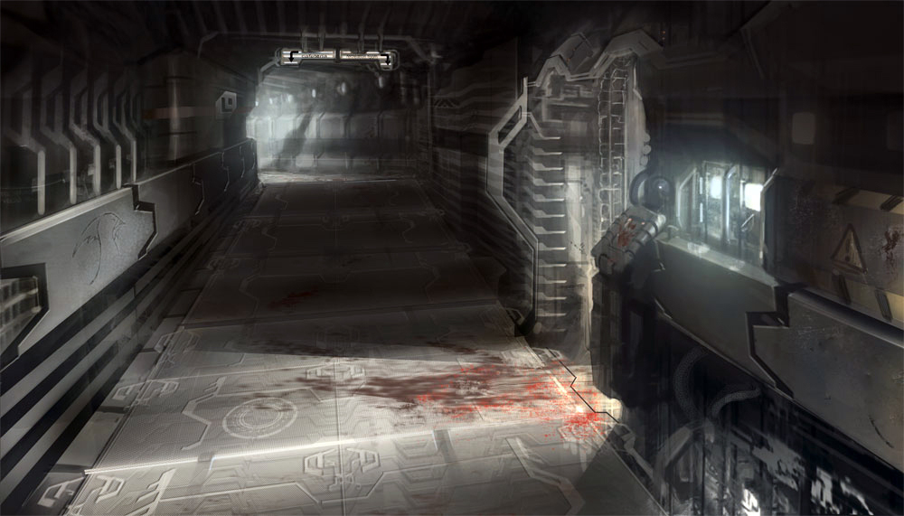
Soma Concept Art Example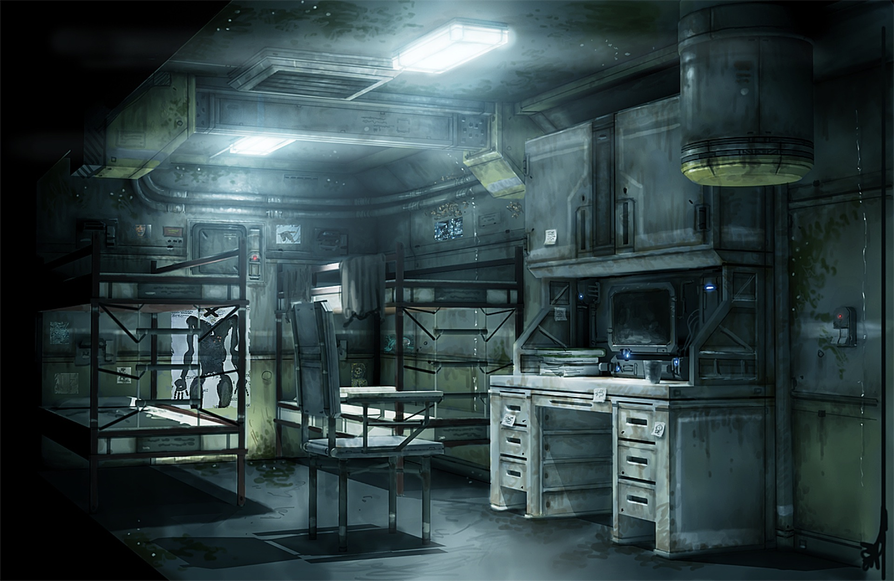

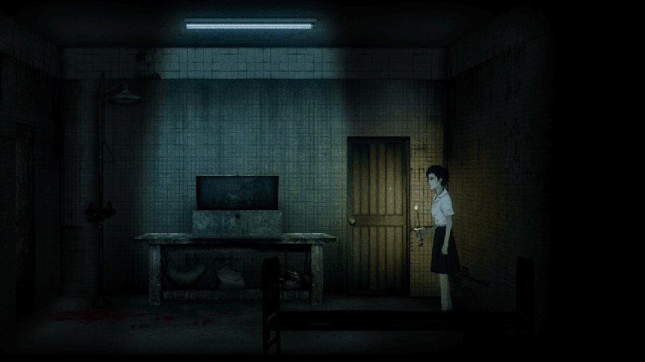Detention Screenshot

Alien Isolation Screenshot
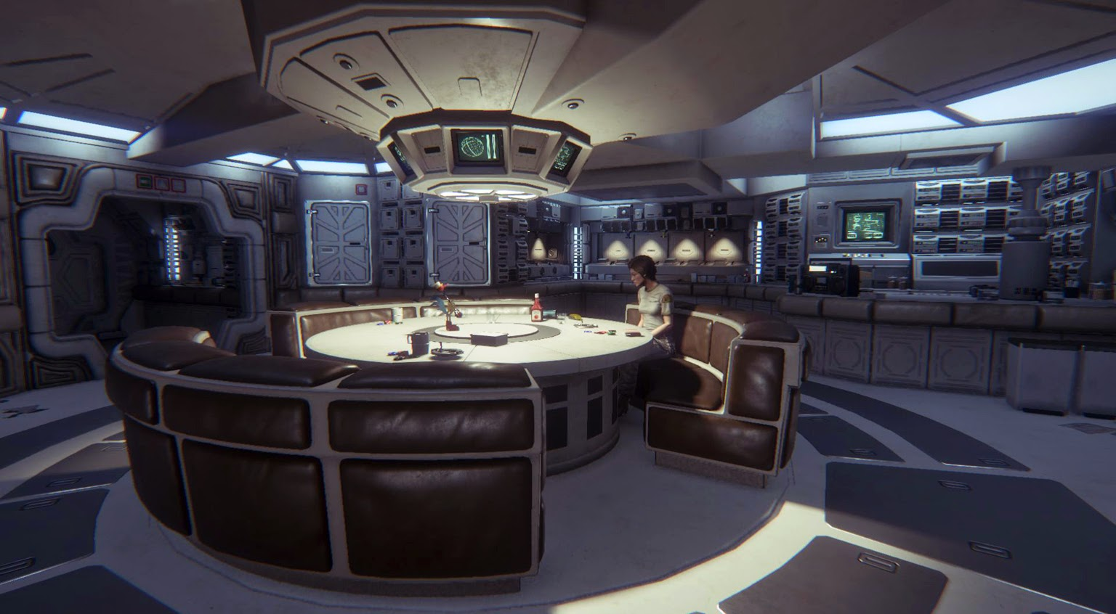

User Interface / Controls

Interface:
The HUD is presented through an edge or corner of the player’s data pad on screen. This will show their current objective and health. Four buttons on the HUD will expand the travel menu, the map, the inventory, and the fourth will call the station’s VI for assistance.

Menus:
The travel menu will first present the player with a list of ‘manipulatable’ physics, such as gravity. When the player selects one, they will be presented with a short list of universes they can travel to with different aspects of the selected physics.
- Home
- Gravity
  - Much Higher
  - Higher
  - Lower
  - Zero
- Speed of Light

The Map will provide a head-on, side by side of each half of the Aspect, with the player’s current room on either side at the top. Rooms will all be indicated as below.

Rec Room

SysOp

The inventory will simply list the items the player currently has, and will include a brief description for highlighted items.

Messaging:
Information will be passed to the player through on-screen textboxes. Time permitting, we may include some small amount of voice-acting for character interactions.

Music and Sound Effects

Music:
We hope to create a dichotomy between moments when the monster is in play and moments when the player can perceive the situation as relatively safe to solve puzzles. The player should feel the unease of their situation in the soundtrack, but ambience is not the only goal. A good soundtrack should be memorable and serve to enhance whatever is being conveyed to the player. These design principles will be kept in mind as we work on the soundtrack.

As for the actual process of generating and implementing the soundtrack, we will be composing tracks in Ableton, then baking them into Gamemaker.

Soundtracks that we can draw reference to as a similar genre and focus could be:
-Silent Hill 2 OST
-Oxenfree OST
-Deadly Premonition OST

Sound Effects:
Interacting with characters and the VI will have a text scroll sound as they talk. The process of fixing the station will result in a variety of sounds, from clanks of machinery starting up to the sound of a ratchet being turned. There should also be ambient sounds not caused by the player - the ship groaning or electrical buzzing, for example. Once the engines are on, there should be a low, constant hum in the background. Fixing the life support system will result in a sudden hiss of air as the system begins renewing it. Moving boxes and other objects could result in sliding or grinding sounds. Occasionally, as the player character works, they may grunt, sigh or grumble - general sounds of exhaustion, exasperation or effort. The player may also hear sounds of objects in space hitting the hull of the station. The monster will let off an unearthly low buzz or moan when on screen or nearby. When the player is being drained by the monster, a warning sound, not too annoying, will play.

